**THADINGYUT FESTIVAL**

The Thadingyut Festival (Lighting Festival of Myanmar) is held on the full moon day of the Myanmar Lunar month of Thadingyut. It marks the end of the Buddhist lent and is the second most popular festival in Myanmar after Thingyan (Water Festival).

Thadingyut Festival is the celebration to welcome the Buddha’s descent from heaven after he preached the Abhidamma to his mother, who was reborn in heaven. When Lord Buddha descended from heaven, people from all over the country light candles to welcome him back. As years passed by, it became a tradition and a festival.

Thadingyut Festival is also about giving thanks and paying homage to Buddhist monks, teachers, parents and elders, and asking pardon for whatever misdeeds might have been committed during the year. Pagodas, houses, public buildings, parks and monuments are all illuminated and there are various activities for everyone to enjoy.

One famous Pwe Zay (street fair with many stalls and booths) in Yangon is held in Yay Kyaw in Pazzaungdaung Township annually. There are lots of food-stalls that sell a variety of Myanmar Traditional Foods, some of these you can only find during the festival. Many people just walk around the streets for sightseeing and to have fun. You can also enjoy free stage shows on the streets around Yay Kyaw.

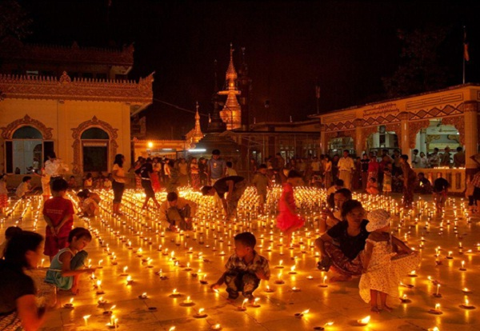

The busiest place for the Lighting Festival is Shwedagon Pagoda and downtown in Yangon. Mandalay also holds the Festival around Kyauk Taw Gyi Pagoda because it coincides with the Pagoda Festival. But sadly, due to Covid, this year everyone has to stay at home. To look on the bright side, we can still celebrate this Thadingyut at home with loved ones happily.

Wishing you all a peaceful and Happy Thadingyut!

*Source: Internet*